Main Post
Student Post
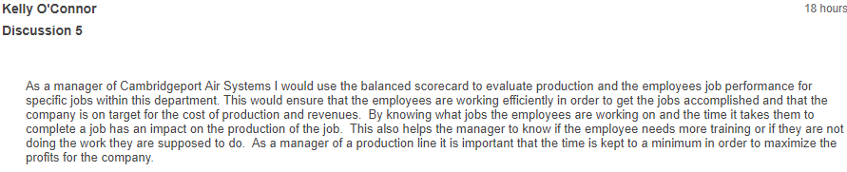
I want you reply one paragraph on that student post
Student Post
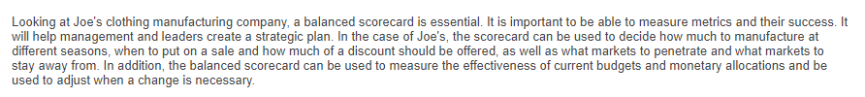
I want you reply one paragraph on that student post

